**Assignment 4**

1. **Please explain what are DFS and BFS, what is the differences between them? (2 scores).**

DFS stands for the depth-first search. The main idea of DFS is “Visit all neighbors of a neighbor before you visiting your other neighbors”.

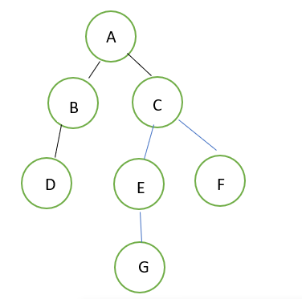BFS stands for the breadth-first search. The main idea of BFS is “Visit all your neighbors, then visit the neighbors of your neighbors”.

Let me explain them in graphs. Taking a binary tree as an example:

Using DFS to find G:

|  |  |
| --- | --- |
| To visit | Visited |
| A | [] |
| BC | A |
| DC | AB |
| C | ABD |
| EF | ABDC |
| GF | ABDCE |
| F | ABDCEG |

Find G, stop searching.

Using BFS to find G

|  |  |
| --- | --- |
| To visit | Visited |
| A | [] |
| BC | A |
| CD | AB |
| DEF | ABC |
| EF | ABCD |
| FG | ABCDE |
| G | ABCDEF |
| [] | ABCDEFG |

Find G, stop searching.

When using BFS, after visiting nodes from the same level, then move to next level. While using DFS, after visiting all nodes from left tree, then move to the right tree.